Magnetic, Electrical and Structural Measurements of Bi₂Sr₂Ca₂(Cu_{1-x}Fe_{x})_{n}O_{10+δ} (x= 0.01 and n=3)

Rohitash Kumar and Yadunath Singh
¹Departrment of Physics, Veena Memorial P.G. College Karauli, Rajasthan INDIA
²Department of Physics, Bikaner Technical University,Bikaner.

rohit_mehariya@yahoo.com
singh_kyn@yahoo.co.in
Abstract.In this research work, we are studying about electric, magnetic, and morphological properties of the sample Bi₂Sr₂Ca₂(Cu_{1-x}Fe_{x})₃O_{10+δ}. The hysteresis curve of the sample show magnetization on the applied magnetic field on ±15k (Oe) and show paramagnetic behavior in the sample and also report a squareness ratio of about 0.2 which, indicate the single magnetic domain produced. The electrical resistance is measured by liquid nitrogen, by the Four Prove method which shows the metal and semiconductingtransition, because the curve is linearly decreasing order nearly 200K temperature. After that, the resistance again slowly increases and shows semiconducting behavior.The morphological data were collected by FE-SEM. These morphological representations show the platelet-type layered position of the sample in the micron range, which is similar to Bi-2223 ceramic superconductor initial growth.

Introduction

To define superconductivity, the Bi-Sr-Ca-Cu-O superconductors were investigated by (H. Maeda et al. 1988) [1]. They observed that the Bi–Sr–Ca–Cu–O (BSCCO) system has three superconducting phases in terms of its chemical compositions, Bi-2201, Bi-2212, and Bi-2223. These superconductors have a 110K critical temperature which develops more interest in their construction [2-4]. The Bi-2223 type superconductors show ceramic properties at room temperature and also show high resistance, but at low temperatures, these showsuperconductivity [5-9].

Here, we have used a Ball mill to grind stoichiometric compounds. Thus, we describe here a systematic investigation of the structural, microstructural, electrical, and magnetic properties of ball-milled ceramic powder Bi₂Sr₂Ca₂(Cu_{1-x}Fe_{x})₃O_{10+δ}. We have focused on the changes in the physical properties of tiny Bi-2223 ceramic powders caused by the progressive milling process and particle size reduction [10-12]. Powder of single-phase Bi-2223 [13-14] was prepared by the traditional solid-state reaction method, then ball milled for different times up to 6 hours and characterized by several techniques, like field emission scanning electron microscopy (FE-SEM), four prove technique, and magnetic field dependence of the magnetic Hysteresis curve.

Experimental Details
The X-Ray diffraction (XRD) study and Fourier Transform Infrared (FTIR) study have already been published for a sample of Bi₂Sr₂Ca₂(Cu_{1-x}Fe_{x})₃O_{10+δ} (x = 0.01) in [15-16]. These studies show the initial growth of the Bi-2223 superconducting phase in the sample and FTIR confirms the bond formation of Bi-2223 phases. Presently, we have considered other experimental properties of this sample Magnetic, Electrical, and Morphological, which are the basic properties of superconductivity.

Magnetic (VSM) and Electrical (four Prove) Properties Measurement
The Magnetic measurement has been carried out using a vibrating sample magnetometer (VSM). A magnetic field of up to ±15K (Oe) was applied to the sample at room temperature. Then the graphical data between applied magnetic field H_{(Oe)} versus magnetization M_{S}(emu/g) was induced automatically. The vibrating sample magnetometer (VSM) gives the hysteresis loop as shown in figure 2.

The Electrical resistance measurement has been carried out using the Four Prove method at liquid Nitrogen temperature as described by Y. Singh [17]. We used silver pests to make the connection to the pellet sample. Then the graphical data between Resistance (R)Ω and Temperature (T)K is induced automatically. The R versus T curve is shown in Figure 2.

Morphological Measurement with (FESEM)
The Morphological measurement has been carried out using Field Emission Scanning Electron Microscope (FE-SEM) at different scales. These are shown in Figure 1. All the images were obtained at room temperature, which shows uniform distribution of particles.
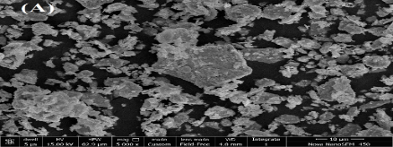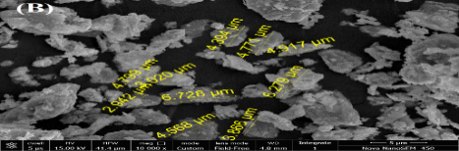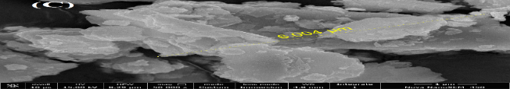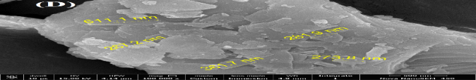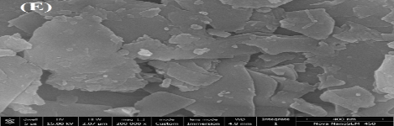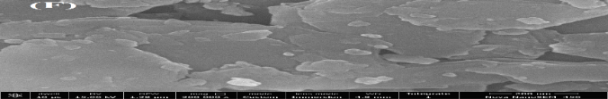

Figure 1.Surface morphological image (A), (B), (C), (D), (E), (F) of sample Bi₂Sr₂Ca₂(Cu_{0.99}Fe_{0.01})₃O_{10+δ}
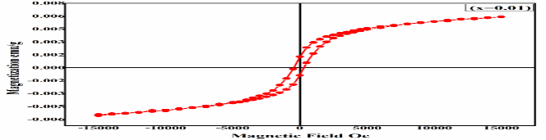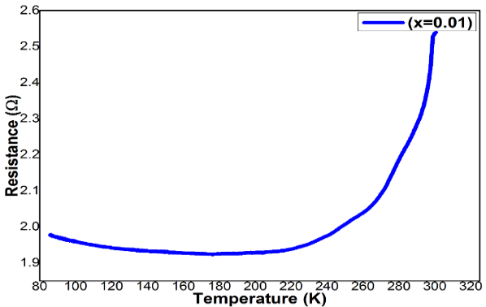

(a) (b)
Figure 2. (a) Hysteresis loop at room temperature of sample Bi₂Sr₂Ca₂(Cu_{0.99}Fe_{0.01})₃O_{10+δ}) and (b) Resistance Versus Temperature curve of sample Bi₂Sr₂Ca₂(Cu_{0.99}Fe_{0.01})₃O_{10+δ}.

Result and Discussion
This section contains the Magnetic, Electrical, and Morphological analysis of the sample. According to the Hysteresis curve, the saturation magnetization (+M_{S}) was observed as 0.000789 emu/g on saturation Magnetic field 14990 (+H_{s}) and remanence magnetization (M_{R}) was observed as 0.000172 emu/g on applied Magnetic field -4(H_{r}) as shown in figure-1. The coercivity (H_{C}) of the sample varies between 505 (-H_{c}) and 400 (+H_{c}). Similarly, in opposite direction, saturation magnetization (-M_{S}) was observed as 0.000742 emu/g on saturation Magnetic field 15006 (-H_{s}) and remanence magnetization (-M_{R}) was observed as 0.000118 emu/g on applied Magnetic field -7 (-H_{r}). The ratio of saturation magnetization and remanence magnetization is called the Squareness ratio (M_{R}/M_{S}). Thus, the calculated value of the Squareness ratio (M_{R}/M_{S}) is found to be 0.2178 at room temperature, and in opposite direction, it comes out to be 0.1591. Therefore, the sample Bi₂Sr₂Ca₂(Cu_{1-x}Fe_{x})₃O_{10+δ} (x = 0.01) shows the paramagnetic behavior [18]. The magnetic behavior of the sample increases resistance in the sample due to their spin and unpaired electrons, which have a magnetic dipole moment and acts like tiny magnets. Therefore, the sample is the form of magnetism and it is weakly attracted by an externally applied field. It forms internal and induced magnetic fields in the direction of the applied magnetic field. The Squareness ratio comes nearly to 0.2, indicating that the sample of a single magnetic domain is produced [19].

The sample Bi₂Sr₂Ca₂(Cu_{0.99}Fe_{0.01})₃O_{10+δ} does not show the superconductivity phenomenon at low temperature with iron concentration (0.01) as shown in figure 1. This sample shows a resistance of 2.5393Ω at room temperature. When we start the cooling process or decrease the temperature by liquid Nitrogen on the sample, then the resistance decreases linearly. The continuous linear behavior of the sample exists at a low temperature of 176.53K with resistance 1.9236 Ω, which shows the metallic transition of the sample. After this observation, it was noticed that the resistance of the sample increases linearly due to low temperature. The linear behavior of the sample was continued at a low temperature of 85.89K with resistance 1.9780 Ω, which shows the insulating and semiconducting transition of the sample. These results show the low grains connectivity and disordered nanoparticles. This insulator or semiconductor behavior can occur due to a deficiency of oxygen or coupling in CuO₂ planes [20-21]. There was no T_{c} and T_{c} onset temperature.

The grain size and structure of the sample were studied using a field emission scanning electron microscope (FE-SEM). The FE-SEM images of sample Bi₂Sr₂Ca₂(Cu_{0.99}Fe_{0.01})₃O_{10+δ} were carried out at micro-scale 10µm, 5µm, 1µm and at nanoscale 500nm, 400nm, and 200nm as shown in figure-3 (A), (B), (C), (D), (E) and (F) respectively. The high voltage of 15kV was applied on the sample surface which produced the magnification of 5000, 10000, 50000, 100000, 200000, and 300000 for the images (A), (B), (C), (D), (E) and (F) respectively. Image (A) at 10 µm represents the random distribution of micro and nanoparticles. Images (B), (C), and (D) show the arrangement of the particle with nano and micro labels as a platelet-like layered structure of the sample Bi₂Sr₂Ca₂(Cu_{0.99}Fe_{0.01})₃O_{10+δ}. Particularly for image (D) at the one-micron range, several plates in layers can be seen clearly, which indicates the initial phase of the Bi-2223 superconductor.

Conclusion
The study of the sample Bi₂Sr₂Ca₂(Cu_{0.99}Fe_{0.01})₃O_{10+δ} shows the initial growth of the Bi-2223 ceramic superconductor. But, it could not get the superconducting transition due to unpaired electrons. Its main cause was that the sample was not heated for the required number of hours. Therefore, the unpaired electrons created the magnetic moment and it made the sample paramagnetic, while a superconductor has diamagnetic properties. So, this sample shows the metal-semiconductor transition at low temperatures.

Acknowledgments
The authors are thankful to Dr. Arun Kumar, Prof., Department of Physics, Himachal Pradesh University, Shimla for providing VSM facilities and having healthy discussions with us. We are thankful to Prof. K. L. Yadav, Department of Physics, I. I. T. Roorkee Uttarakhand for providing electrical resistance facilities at liquid Nitrogen temperature. We are also thankful to MNIT, Jaipur (Rajasthan) for providing FESEM data. We convey our thanks to U.G.C., New Delhi for proving the financial assistance to carry out this work.

References
- H. Maeda, Y. Tanaka, M. Fukutomi, “A new high-Tc oxide superconductor without a rare earth element”, Jpn. J. Appl. Phys. 27: (1988) L209-L210.
- G. Ilonca, T.R. Yang, A.V. Pop, G. Stiufiuc, R. Stiufiuc, and C. Lung; Physica, (2003), C388-389, 425.
- S. B. Mohamed, S. A. Halim, H. Azhan, IEEE Transaction on Applied Superconductivity, (2001), 11, 2862.
- I. H. Gul, Rehman, M. Ali and A. Maqsood; Physica C432 (2005), 71.
- Reynald Passerini, “Docteur en Science” Thesis, Universite de Geneve (2002).
- I. Chong, Z. Hiroi,M. Izumi, J. Shimoyama, Y. Nakayama,K. Kishio, T. Terashima, Y. Bando and M. Takano, Science 276, (1997), 770.
- J. Shimoyama, Y. Nakayama, K. Kitazawa, K. Kishio and Z. Hiroi, I. Chong, M. Takano, Physica, (1997), C281 69.
- J. Shimoyama, K. Murakami, K. Shimizu, Y. Nakayama and K. Kishio, Physica C357-360, (2001), 1091.
- H. Salamati, P. Kameli and F. S. Razavi, Supercond. Sci. Technol. 16, (2003), 922.
- H. L. Liu, M. A. Quijada, A.M. Zibold, Y. D. Yoon, D. B. Tanner, G. Cao, J.E. Crow, H. Berger, G. Margaritondo, L. Forrk, B. Hoan, J.T.Markert, R.J. Kelly and M. Onellion, J. Phys.: Condens. Matter 11, (1999), 239.
- X F. Sun, X. Zhao, X.-G. Li, and H. C. Ku; Phys. Rev. B59, (1999) 89 78.
- Y. K. Kuo, C. W. Schneider, M. J. Skove, M. V. Nevitt and G. X. Tessema, Phys. Rev. B56, (1997), 6201.
- H. L. Liu, D. B. Tanner, H. Berger and G. Margaritondo, Physica C311, (1999), 197.
- Ernesto Govea-Alcaide, Lázaro Pérez Acosta and R. F. Jardim, “Diamagnetic, paramagnetic, and ferromagnetic properties of ball milled”, Bi_{1.65} Pb_{0.35} Sr₂ Ca₂ Cu₃ O_{10 + δ} powders Article in Journal of Nanoparticle Research · November (2015). DOI: 10.1007/s11051-015-3231-y.
- Rohitash Kumar, H. S. Singh, and Yadunath Singh, “Synthesis and Structural Characterization of Bi₂Sr₂Ca₂(Cu_{1-X}Fe_{X})_{n}O_{10+δ} (x= 0.01, n=3)”, AIP Conf. Proc. 1953, 120001-1–120001-4, (2018). https://doi.org/10.1063/1.5033066.
- Rohitash Kumar, H. S. Singh, and Yadunath Singh, “FTIR Characterization of Bi2Sr2Can-1(Cu1-xFex)3O10+δ with (n=3, x= 0.01) Ceramic Superconductor”, AIP Conf. Proc. 1953, 030001-1–030001-4, (2018). https://doi.org/10.1063/1.5032336.
- Y. Singh, International Journal of Modern Physics: Conference Series 22 (2013) 745.
- Dho J., Lee E.K., Park J.Y., Hur N.H., J. Magn. Magn. Mater. 285, (2005), 164-168.
- Jotania H., Khomane R., Deshpande A., Chauhan C. and Kulkarni B., J. Sci. Res.1(1), (2009), 1-13.
- David Schmool; et al., “Introductory Solid State Physics”, MedTec Introductory Physics Series: edition (2014).
- S.X. Dou, Y. J. Sheng; et al., “Effect of Fe Doping on Superconductivity in the Bi-Pb-Sr-Ca-Cu-O System”, Modern Phys. Lett. B, Vol. 4, No. 22, (1990), 1393-1402.

